**Formative Assignment 1**

|  |  |
| --- | --- |
| Module Name | Application Implementation (Agile Project Management) |
| Course Name | Bachelor of Technology in Software Engineering |
| Assignment Title | Project Management Plan for implementing the community portal |

|  |  |
| --- | --- |
| Learner Name | Muhammad Kemal |

|  |
| --- |
| Learner declaration |
| I certify that the work submitted for this assignment is my own and research sources are fully acknowledged.  Student signature:  Date: 19-0 7-2023 |

## Purpose of this assignment

To demonstrate your capabilities in the following areas:

* Preparing Requirement Specifications
* Developing Project Plan

## Submission Format

The submission is in the form of an individual written report with examples and illustrations. This should be written in a concise, formal academic style using single spacing and font size 12.You are required to make use of headings, paragraphs, and subsections as appropriate, and all work must be supported with research and referenced using the Harvard referencing system. Please also provide a bibliography using the Harvard referencing system.

## Submission file

Submission File Name format: Cohort Code _Full Name_Assignment Number

E.g.: AIM-1222A_AliceTan_A1.docx

## Scenario

## You have been approached by ‘ABC Jobs Pte Ltd’ as a website developer to develop a community portal for Software Developers. For this module the scope is to Design, Develop, Implement & Document the data-driven website using the framework Spring boot and react.

The Scope of the Project is to design a Community Portal Similar to Linkedin.com. Users will be able to register in the portal using the Registration Page. Users of the portal can search for other users using various parameters such as First Name, Last Name, Company Name, City & Country. Users will be able to view the Public Profile of users after searching them. The portal allow users to login, request for forgotten password and Update their profile information.

The overview of the project is as below

There are 2 types of users in this Community portal. They are

1. Software Programmer
2. Administrator

## Software Programmer should be able to perform following functions in the portal

## 1. Allow the programmers to register in the portal, show a thank you page & send a registration confirmation email.

## 2. Search & Find Other Programmers after login and view their profile.

## 3. Provide Login Page

## 4. Provide password retrieval functionality.

## 5. Update their Profile after logging in.

## Following Functionality is part of Database Design & Will be enhanced as features as required in the Capstone Project, Depending on time availability.

## 6. Send Messages to Each Other on the Portal

## 7. Create Threads & Post Replies to a Thread

## 8. Post Job Opportunities in the Portal

## Administrator should be able to perform following functions in the portal

## 1. Administer user data.

## 2. Send bulk email inviting programmers to register on the community portal

## The portal consist of the following Key pages (For Reference)

## 1. Community Portal Home Page

## 2. Registration Page

## 3. Registration Confirmation Page

## 4. Update Profile Page

## 5. Search Users Page

## 6. List Search Results

## 7. Public Profile Page

## 8. Registration Confirmation Email

## 9. Login Page

## 10. Forget Password Page

## 11. Design the Forget Password Confirmation Page

## Following Functionality is part of Database Design & Will be enhanced as features as required in the Capstone Project, Depending on time availability.

## 

## 12. Send Messages

## 13. Read Messages

## 14. Post in Message Board

## 15. List Message Board

## 16. Read A Thread

## 17. Post Job Opportunities

## 18. List Job Opportunities & Responses

## You will be required to:

* Write a brief requirement specification for the Community Portal.
* Prepare the detailed project plan to implement the Community Portal

## Evidence to exhibit

* Requirements Specification
* Project Plan

1. **Write a brief requirement specification for the Community Portal.**

# Functional Requirements

|  |  |  |  |
| --- | --- | --- | --- |
| No | Requirements | Web Page / Process | Field detail |
| 1. | On the register page, users can register their information. | Registration | Logo, Registration Image, Form Fields, Hyperlinks, Buttons, Copyright. |
| 2. | After registering, users may receive a message of confirmation. | Registration Confirm | Button, Message field. |
| 3. | Users are able to log in using data from the database. | Login | Logo, Login Image, Text Fields, Hyperlinks, Buttons, Copyright. |
| 4. | Users who forget their passwords can change them and re-enter the system. | Forget Password | Logo, Input Fields, Button, Copyright. |
| 5. | After successfully logging into the system, users can update their profiles. Education and experience can be added by users. | Update Profile | Biodata Section, Education Section, Experience Section, Button, Name Section, Background Image,  Footer, and Copyright. |
| 6. | Users can search for other users. | Search | Search Field, Search Button, Search Results Page, Profile Preview Section. |
| 7. | Users can see the search result. | Search Result | List of Profiles, See Profile Button. |
| 8. | Users can view other users’ profiles. | Others Profile | Others Profile Preview Section. |
| 9. | Users can Read and react to a thread. | Homepage | Thread section, My Profile Section, Footer Section |

* 1. Non-Functional Requirements

|  |  |  |
| --- | --- | --- |
| No | Requirements | Purpose |
| 1 | Performance | Make sure the Community Portal runs well and reacts to user actions promptly. |
| 2 | Availability | Make sure there are few downtimes when the Community Portal is usable. |
| 3 | Security aspects | Ensure data privacy, safeguard user data, and stop illegal access. |
| 4 | Database backup | Maintain regular database backups to guard against data loss and facilitate recovery in the event of problems. |

# Technical requirements

Hardware

* + - Memory: 4 GB.
    - Graphics Card: 11th Gen Intel(R) Core(TM) i3-1115G4
    - CPU: Dual Core CPU.
    - OS: Windows 10 / 11
    - Database server – MySQL server
    - Firewall settings - Port 9091 -- Http

- Port 3000 – Database

Software

* + - Eclipse IDE: Install the Eclipse IDE for Java EE Developers by downloading it. Make sure the version you choose has the plugins and tools required for Spring MVC development and supports Java EE development. Version 4.26.0 of Eclipse
    - Spring Framework: Download and include the Spring framework libraries in your project. (Spring framework 5.2.10)
    - Install a servlet container on your computer, such as Apache Tomcat. For the Spring MVC application to be deployed and execute, we require it. Make sure the servlet container is appropriate for the Spring framework version you're using. (9.0 Apache Tomcat)
    - Maven or Gradle: A build automation tool like Maven or Gradle can simplify the project setup and manage dependencies effectively.
    - Java Development Kit (JDK): Install the latest version of JDK on your system. Eclipse requires a compatible JDK to run. (JDK 18.0.2)

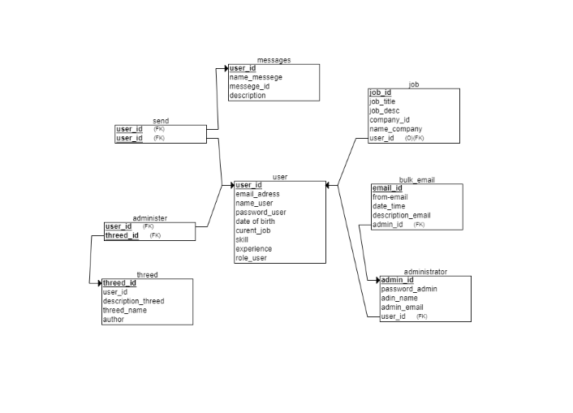

Database

* + - MySQL Workbench 8.0. (MySQL Server 8.0.31)



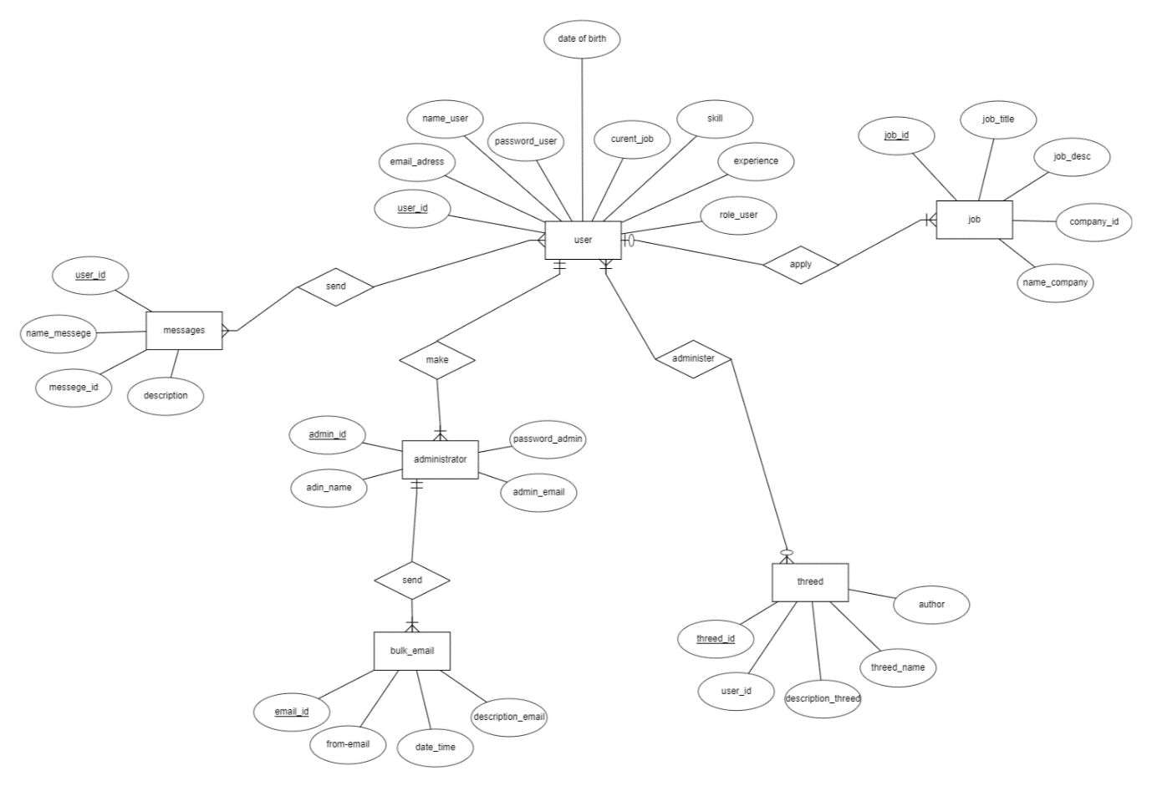

1. Prepare a detailed project plan to implement the Community Portal

# Wireframe

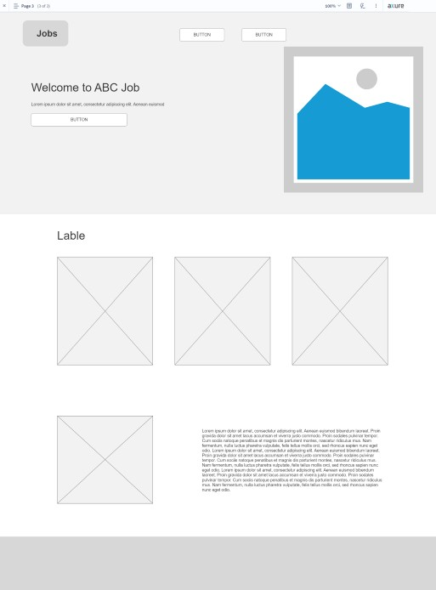

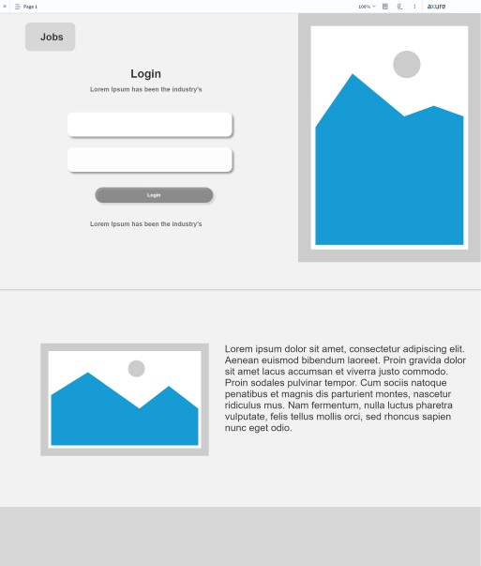

# 

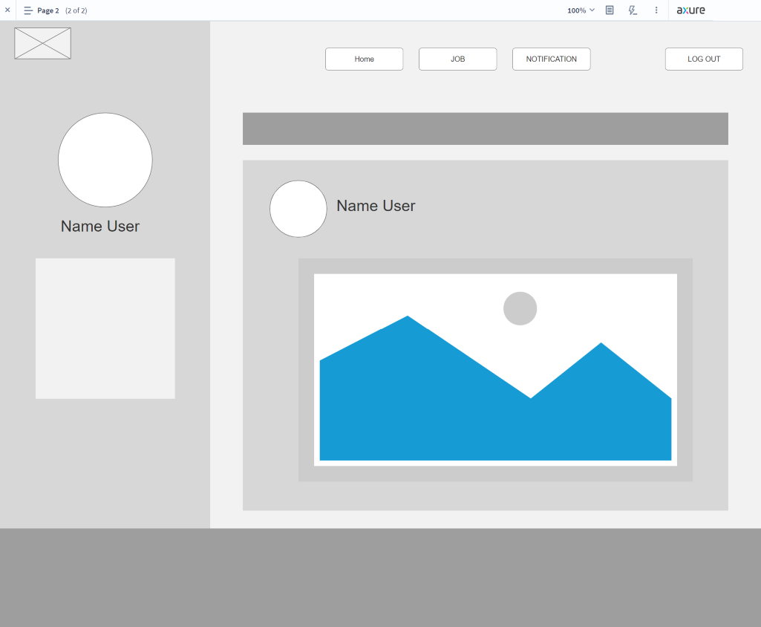

* 1. Stories board

Slebew was looking for a job in the community portal, so he went to the ABC job website then he searched for a company in the search, then he chose a company, then was directed to the company details and he agreed and clicked the apply button.

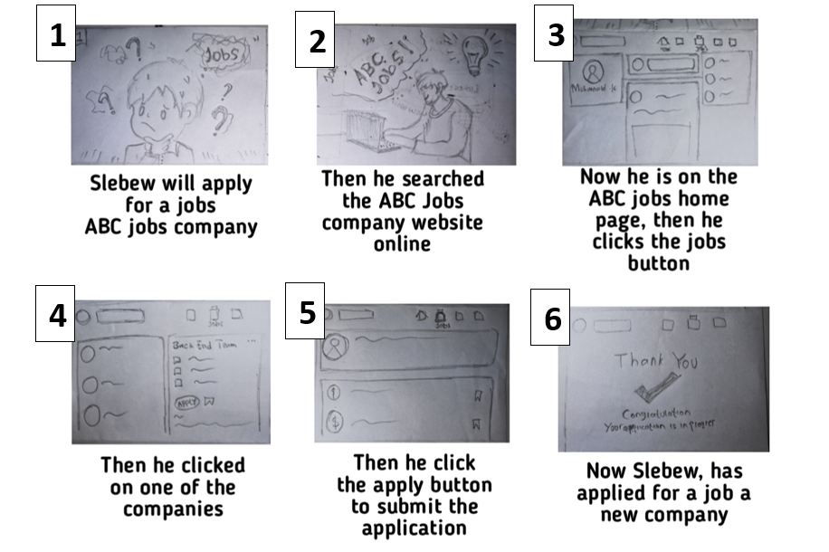

# Persona

|  |  |  |
| --- | --- | --- |
| No | Persona | Brief Description |
| 1 | Slebew wow | Slebew is interested in front-end web developers. |
| 2 | Jhon anjay | Jhon wants to join in order to gain work experience |

|  |  |
| --- | --- |
| Persona (1): | Slebewi Wow |
| Demographics: | * Age               : 25 Years * Nationality    : Mexico * Gender          : Male * Job                : Full Stack Developer |
| Behaviors and Beliefs: | * IT Enthusiast * Want to master programming |
| Characteristics: | * Strong will * Caring person |
| Goals: | * To find job that suits him |

|  |  |
| --- | --- |
| Persona (2): | Jhon Anjay |
| Demographics: | * Age               : 28 Years * Nationality    : Rusia * Gender          : Male * Job                : Front End Developer |
| Behaviors and Beliefs: | * Always have great ideas * want to try to give the best performance |
| Characteristics: | * Strong will * Extrovert |
| Goals: | * I have no trouble selecting all the option I desire * The amount of content makes it pretty fascinating |

* 1. Project Plan
     1. Gantt Table

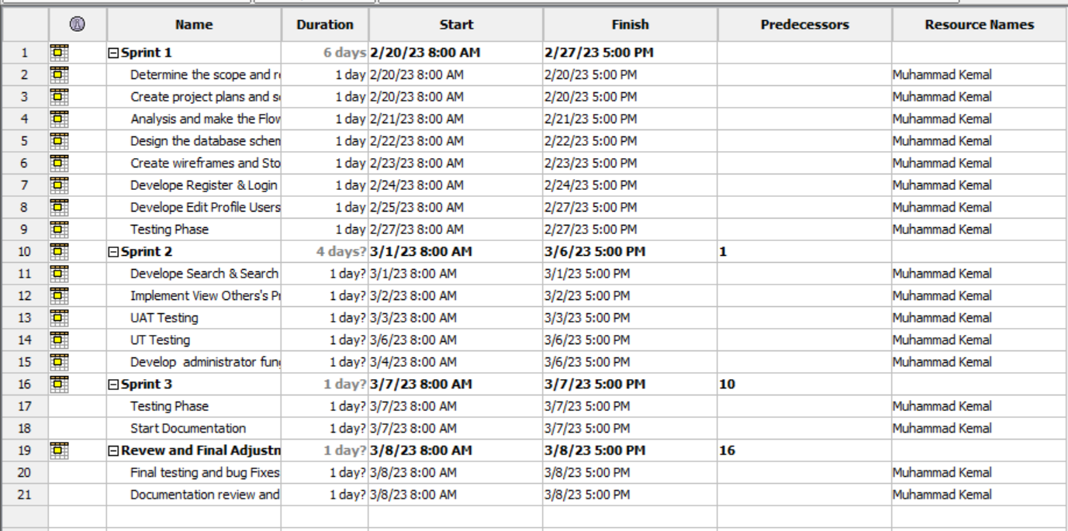

* + 1. Gantt Chart

